Department | Analytical Research & Development

ISMS Class: Internal

- Objective

The objective of this report is to draw conclusions based on the verification conducted on the Test procedure (ANAI-PD-0192.04) for the estimation of Acetic acid in Enzalutamide API using HPLC.
Limited parameters have been studied as the analytical method was validated and verified at the customer site.

- Responsibility
Scientist/Team Member AR&D is responsible for the execution of method verification and preparation of method verification report.
Team Leader/Group Leader AR&D or designee shall review and ensure compliance.
DQA/QA is responsible to approve the method verification report.

- References
Method validation SOP: SOP-GLOB-QC-0008, Version*
Work instruction on Validation of Analytical Test Procedure for preservatives, antioxidants, and other content methods by Liquid Chromatography: WI-GLOB-QC-0557*
Documenting the Research data in E-Lab Notebook (ELN) SOP: SOP-CDM-RD-0061*
Test Method Reference No: ANAI-PD-0192.04
Specification No.: QC-FPEI-001/05
Protocol No.: PR-CDM-000643
* Current Versions

- Method Verification Parameters Executed
- System Suitability
- Specificity
- Batch Analysis
- Method Precision
- LOQ Precision

Note: LOD & LOQ Established values were considered from API validation report which was executed customer site.
- Selection of Batch
The analytical method verification was conducted on the drug substance batch number Elm0030819. The CoA for the same was obtained from the supplier/vendor for the study.

- Instrument, Solvent and Analysts Details
Following instruments were used for method verification activities
Name of the Instrument | ID | Make | Calibration Due date
Analytical balance | CDM-AR&D-AB-0184 | Sartorius | 20-09-2023
HPLC Column | CFLC-1211 | Kromosil | NA
Ultrasonic water batch | CDM-AR&D-SON-0321 | Powersonic | 05-08-2023
Micro pipette | CDM-RD-PIP-1063 | Transfer | 08-08-2023
HPLC | CDM-AR&D-HPLC- 0174 | Waters | 16-09-2023
HPLC | CDM-AR&D-HPLC- 0172 | Agilent | 02-09-2023

Following solvents/chemicals were used for method verification.
Name of the Solvent | Make | Grade | Batch No.
Dichloromethane | Merck | HPLC | SD3SF73801
Orthophosphoric acid | Merck | HPLC | D12D721498
Acetonitrile | Standard | HPLC | SR/0390523072

Following standard was used for method validation.

S. No. | Standard | Make | Batch number | Valid up to
1 | Acetic acid | Merck | K53468663 | 20-06-2026

- Test Procedure

Acetic acid content by HPLC:
Chromatographic conditions:
Equipment : A liquid chromatograph equipped with variable
wavelength UV- Detector
Column : Kromasil 100-5-C18, 250 x 4.6 mm, 5µm Make: Akzo
Nobel; Part No: M05CLA25]
Flow Rate : 1.0 mL/minute
Wavelength : 205 nm
Column temperature : 25°C
Auto sampler temperature : 5°C
Iniection Volume : 15 µL
Runtime : 30 minutes
Diluent : Dichloromethane: Acetonitrile (90:10) v/v
Elution : Gradient
Buffer : Transfer accurately about 1.0 mL of Orthophosphoric acid (85%) in to 1000 mL of milli-Q water, mix well. Filter this solution through 0.22 µm Nylon filter.
Mobile phase-A : Buffer
Mobile phase-B : Acetonitrile: Water (90:10 v/v)
Note: The mobile phase solution is stable upto 48 hours at room temperature.

Gradient program
Time (in min) | Mobile Phase-A% | Mobile Phase-B%
0.01 | 100 | 0
8 | 100 | 0
10 | 0 | 100
20 | 0 | 100
20.1 | 100 | 0
30 | 100 | 0

Acetic acid standard stock solution Preparation (5000 ppm): Weigh accurately 100 mg of Acetic acid into a 20 mL of volumetric flask, containing about 15 mL of diluent and mix well. Make up to the mark with diluent and mix well.
Acetic acid Standard solution preparation : Transfer 2.0 mL of Acetic acid standard stock solution into a 100 mL of volumetric flask, containing about 75 mL of diluent and mix well. Make up to the mark with diluent and mix well. (100 ppm) The above solution is having about 5000 ppm of Acetic acid with respect to sample concentration [20.0 mg/mL].
Test solution preparation-1: Weigh accurately about 100 mg of sample and transfer into a 5 mL volumetric flask, add about 3 mL of diluent and sonicate to dissolve. Make up to the mark with diluent and mix well. (20 mg/mL)
Test solution preparation-2: Weigh accurately about 100 mg of sample and transfer into a 5 mL volumetric flask, add about 3 mL of diluent and sonicate to dissolve. Make up to the mark with diluent and mix well. (20 mg/mL)
Note: The sample solution is stable upto 48 hours at room temperature.
System suitability: Inject six replicates of the standard solution into the liquid chromatographic system and calculate the mean area and % of Relative standard deviation (RSD) of six replicate injections. The system suitability test must meet the % of RSD for the following acceptance criteria.
A) Relative standard deviation : Not more than 5.0%
Procedure: After equilibrating the column, follow the order of injections and record the chromatograms. Integrate only Acetic acid peak. Calculate the amount of Acetic acid detected by using the following formula.
S.No. | Solution Name | No. of Injections
1.0 | Diluent as blank | Confirm neat blank
2.0 | Standard solution | 6
3.0 | Diluent as blank | Confirm neat blank
4.0 | Test solution preparation-1 | 1
5.0 | Test solution preparation-2 | 1
6.0 | Bracketing Standard solution | 1

Content of Acetic acid in ppm:
AA Area in Spl Wt of the AA in Std stock soln 2.0 mL dil. of the Spl (in mL)
= --------------------x---------------------------------- x ------ x------------------------ x 10⁶
Avg.area of AA in Std 20 mL 100 mL Wt. of the Spl in mg
Where:
AA : Acetic acid
Std : Standard
Spl : Sample
Dil : Diluent

- Method Verification Data

8.1 System Suitability:
The Standard solution was prepared by using Acetic acid standard and injected into the HPLC system. The system suitability parameters were evaluated and found to be within the limits.
For Blank and standard chromatograms refer Annexure, Result ID No.:2345 and 2348, respectively.
Table 1A: Results of System Suitability
System suitability parameters | Observed value
% RSD for acetic acid peak areas for replicate standard injections | 1.50%

Reference: AR No 216390 under ENZ-AMD-NB1 note book.
Acceptance Criteria:
The percent relative standard deviation of the area of acetic acid peak shall be not more than 5.0%.

Inference:
The system suitability results met the acceptance criteria set forth for the method and hence column, system, and method were considered suitable for analysis.

8.2 Specificity:
The specificity study was conducted by preparing and injecting blank solution, Standard solution, as such sample and spiked sample solution into the chromatograph equipped with PDA detector.
Table 2A: Blank Interference

Name of the solution | Preparation No | % Interference
Blank preparation | Preparation-1 | Nil
Blank preparation | Preparation-2 | Nil

Table 2B: Peak Purity Details

S.No. | Standard/Sample Details | Retention Time | Acetic acid Peak
S.No. | Standard/Sample Details | Retention Time | Purity Angle | Purity Threshold | Purity Flag
1 | Standard | 5.541 | 1.38 | 10.24 | No
2 | As such Sample | Not Detected | NA | NA | NA
3 | Spiked Sample | 5.557 | 1.436 | 5.802 | No

Reference: ARNo 216390 under ENZ-AMD-NB1 note book.
Acceptance Criteria:
- System suitability requirements shall meet.
- There should not be any interference from blank at the retention time of acetic acid peak.
- Acetic acid peak, purity angle should be less than purity threshold.
- The peak should not have any Flag in purity results table (For Waters Empower software).

Inference:

No interference from the blank solutions at the retention time of acetic acid peak was observed. The purity angle found less than Purity threshold and no purity flag was observed in the analysed standard & spiked sample conditions for acetic acid peak. This indicates that there is no interference from any solvents / eluents in quantitating acetic acid.

8.3 Batch Analysis:

The batch chosen for the study was prepared in duplicates as per the test procedure and evaluated for the content of acetic acid by analysing using HPLC.

Table 3A: Results from Batch Analysis
Batch Analysis | Observed value (ppm)
Preparation-1 | ND
Preparation-2 | ND
Mean Content (ppm) | ND

Reference: AR No 216394 under ENZ-AMD-NB1 note book.
Acceptance Criteria:
Acetic acid content (ppm) from sample preparations should not more than 5000 ppm.
Inference:
The results obtained are well within the acceptance limits.

8.4 Method Precision:
Repeatability
Precision of the method was demonstrated by spiking acetic acid at 100% specification level (5000 ppm) on the sample. The samples were prepared in six replicates and analysed. Content of acetic acid, its %RSD and 95% confidence interval were calculated and reported.
Table 4A: Results of Method Precision
Sample No. | Acetic Acid content (ppm)
1 | 5643
2 | 4970
3 | 5021
4 | 5644
5 | 4911
6 | 5087
Average | 5213
% RSD | 6.50
95% Confidence Interval | 4941.6349 & 5483.6984

Reference: AR No 216394 under ENZ-AMD-NB1 note book.
Acceptance Criteria:
The percent relative standard deviation (% RSD) of acetic acid peak content in ppm from the six precision sample preparations should be less than 10.0 %.

Inference:

The results obtained are well within the acceptance limits.

8.5 LOQ Precision:
Precision at about Limit of Quantification (LOQ) was evaluated by spiking acetic acid on the diluent in six replicates. The solutions were prepared and analysed using HPLC. Calculated and reported the %RSD for acetic acid.

Table 5A: Results of LOQ Precision

Sample No. | Acetic acid Area (at LOQ)
1 | 3352
2 | 3814
3 | 3659
4 | 3016
5 | 3841
6 | 3886
Average | 3595
% RSD | 9.57

The USP s/n obtained for the first sample is 11.4.
Reference: AR No 216394 under ENZ-AMD-NB1 note book.
Acceptance Criteria:
- The % RSD of the acetic acid peak area from six preparations should be not more than 15.0.
- The USP S/N Ratio should be above 10
Inference:

The results obtained are within the acceptance limits.

Conclusion
All the attributes evaluated under the analytical method verification for the content determination of acetic acid from Enzalutamide API were found satisfactory.
Based on the verification parameters, the method is found to be Precise, Specific and shall be adopted for routine testing.

- Annexure (Chromatograms)

Annexure – 1 Chromatogram of Blank
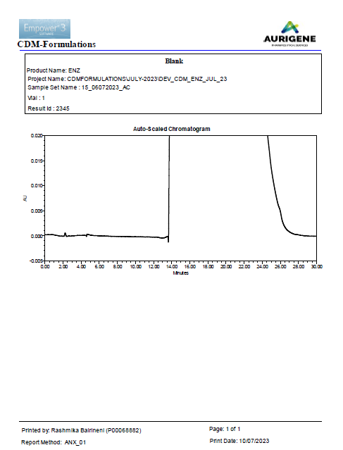

Annexure – 2 Chromatogram of Standard
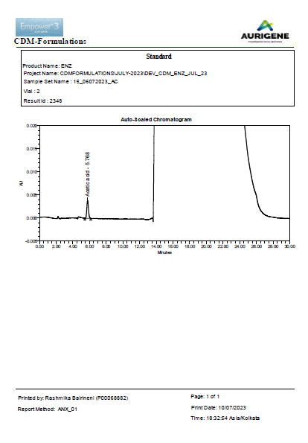

Annexure – 3 Chromatogram of Sample
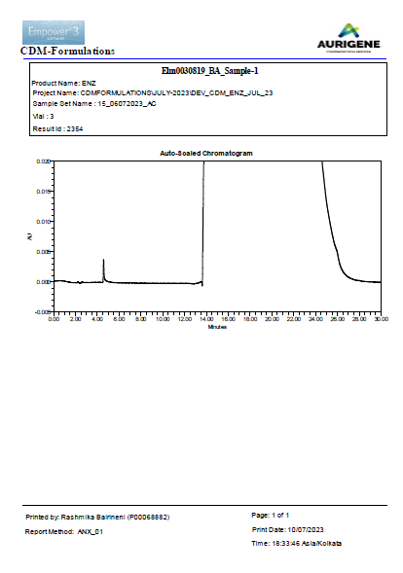
Annexure – 4 Chromatogram of Spiked Sample
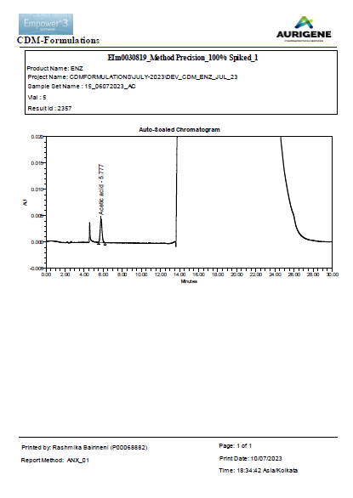
Annexure – 5 Chromatogram of Standard Peak purity
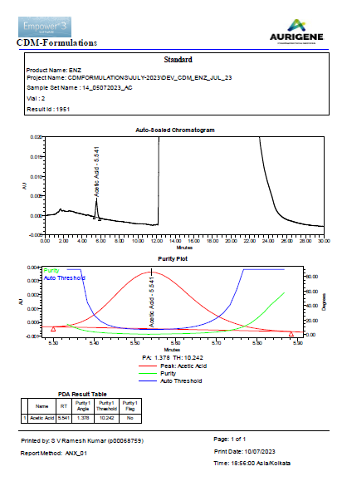
Annexure – 6 Chromatogram of Spiked Sample Peak purity

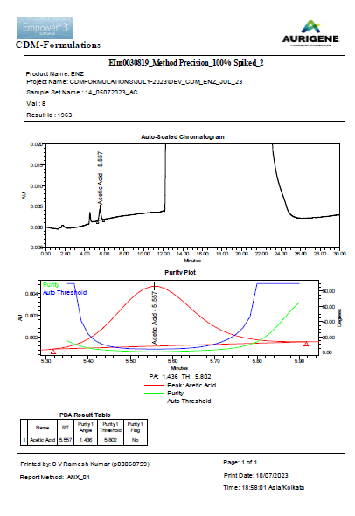

Method validated at Vendor (MSN) site.

